**KEY SB pages 60-61**

**Episode 4 – Practical English: Getting Lost**

A Free Morning

1-a)

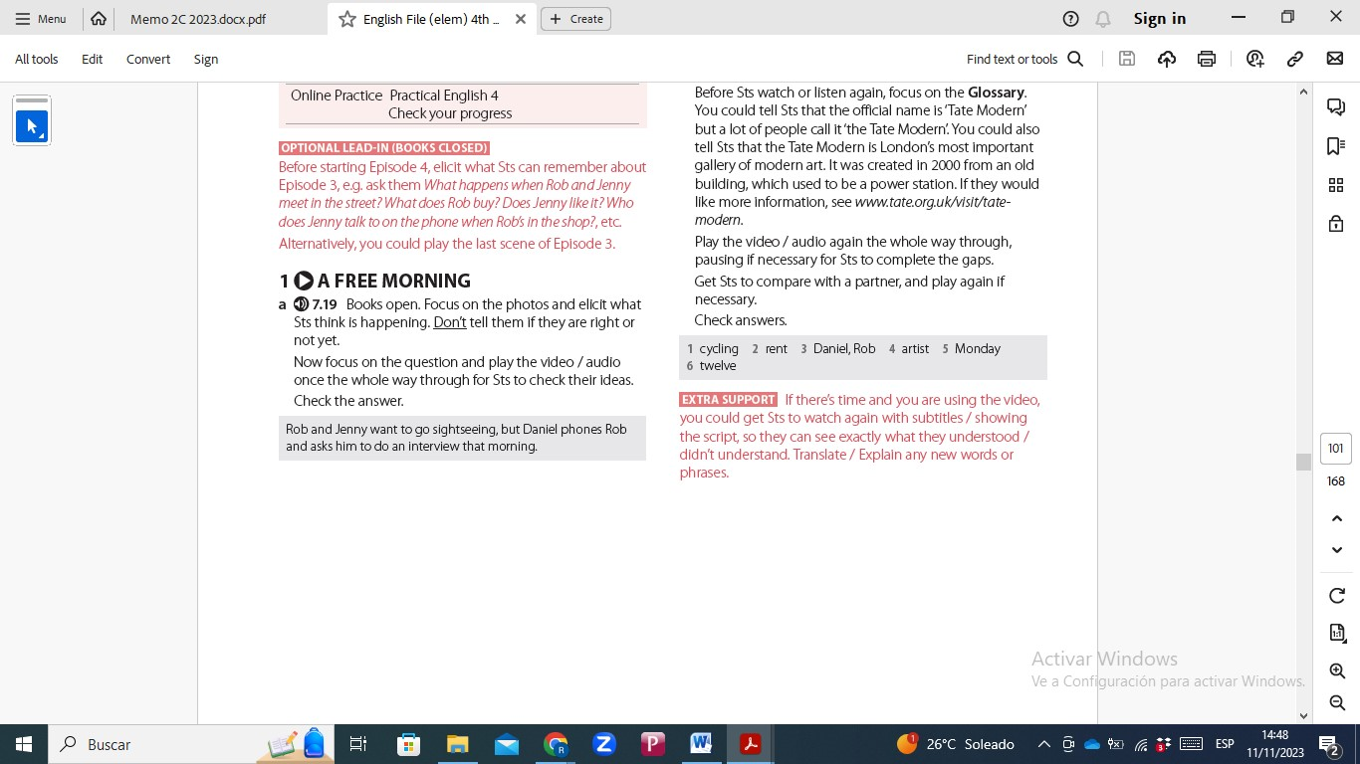

b)



VOCABULARY: Directions

2-a)

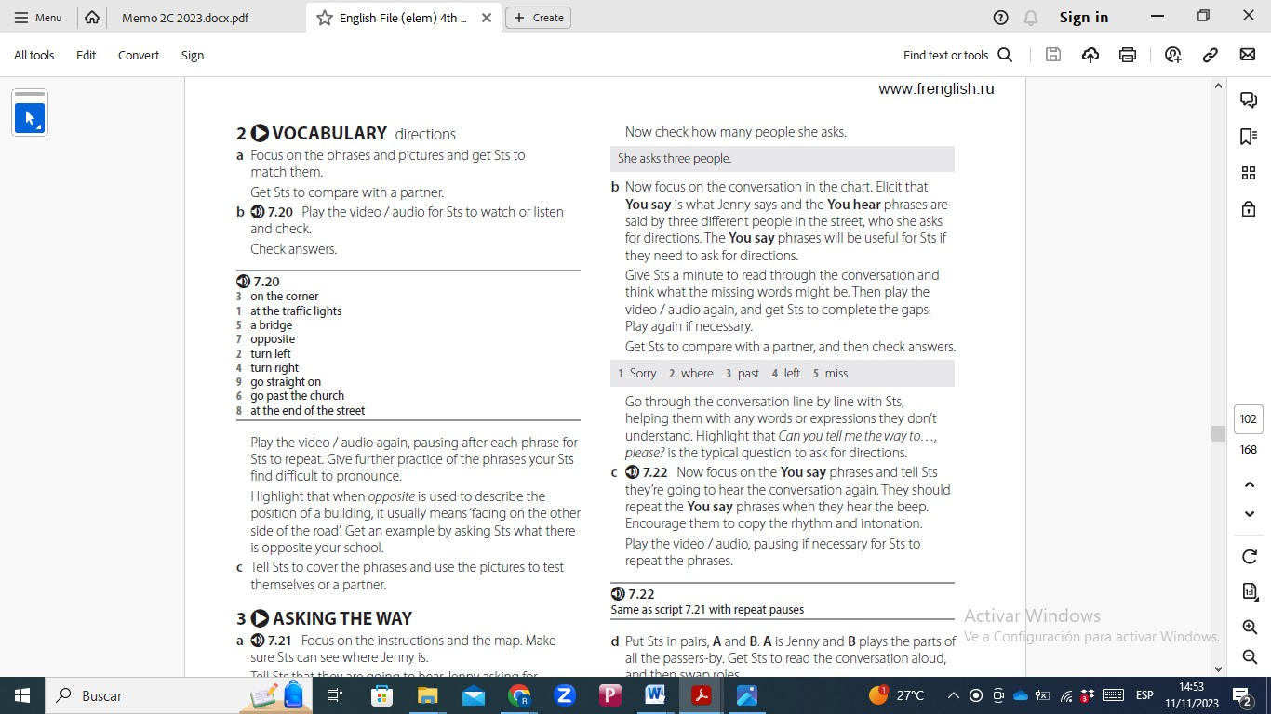

ASKING THE WAY

3-a)She asks three people.

b) 1.Sorry 2.where 3.past 4left 4.miss

JENNY AND ROB GO SIGHTSEEING

4-a)

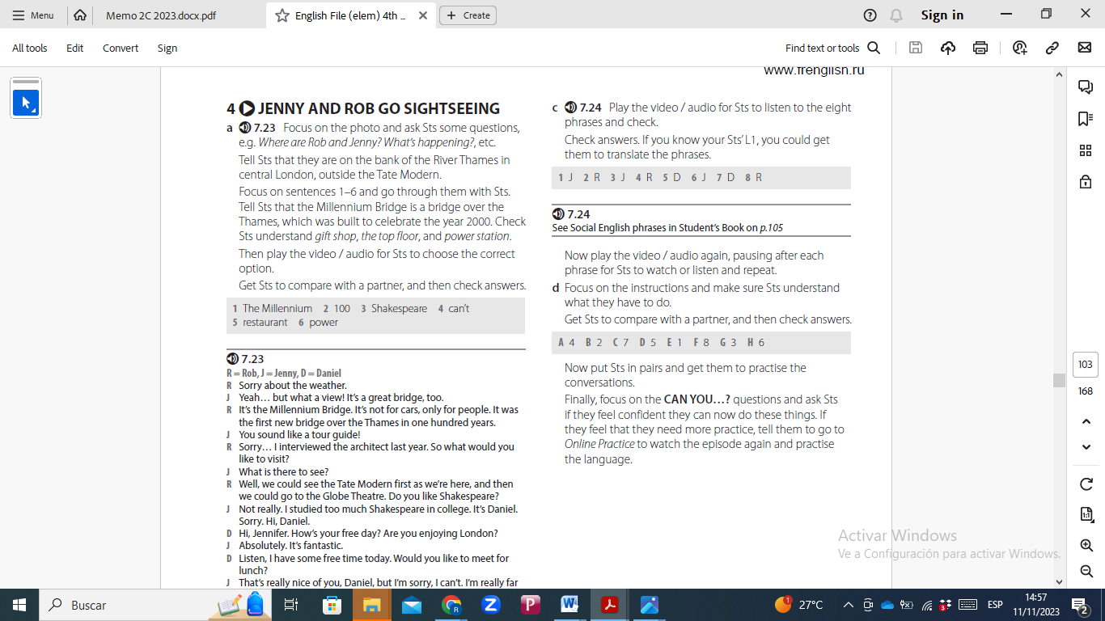

b)



d)

